Disturbing Arctic Methane Facts
In 2009 at lunch break I caught the tail end of a global warming documentary on LINK TV. They were summarizing their projection. First, they saw the permafrost thawing and methane being released. This caused the temperature to rise. After twenty-five years the oceans had warmed some 5°F and they started releasing methane. The temperature curve went parabolic leading to an Age of Mass Extinctions:
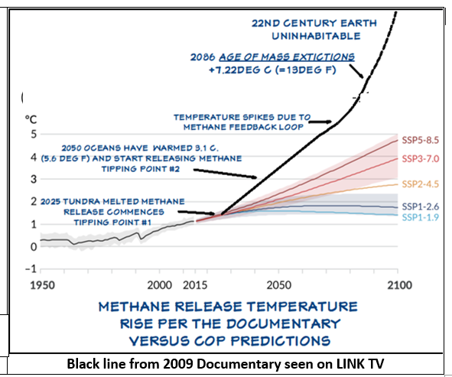
In 2023 I retired and decided to find a climatologist to see where things stand, like had they seen the documentary and its implications. I go to UCAR (University Corporation of Atmospheric Research) and walk in on a conference of polar climatologists. I am introduced to the coordinator Mike Patterson. He explains the following:
The COP, Conference of Parties is the UN appointed organization in charge of informing and directing Climate Change Action. Under them are: The research/data group, the IPCC ( Intergovernmental Panel on Climate Change), then The Climate Modelers, the CMIP (Coupled Model Intercomparison Project).
He has not seen the documentary and says methane is a hot topic, but they do not have any data.
I look at the presentation boards and email and phone the local presenters. None reply. Then I remember a college friend that went on to have a career in atmospheric physics. Gilles Sommeria, worked at the WMO (World Meteorological Organization) and was on the team that handled the data relay from the IPCC to the CMIP. He said: No Hypothesizes were allowed. I am stunned! COP going on 30 years and not allowing postulation about arctic methane in its projections. Could such be considered valid?
Factually the web provides the following key information:
The amount of CO2 that renewables have cancelled out: 2.6Gt (gigatons)
Amount of Methane in Permafrost area: hundreds of Gt (choose 200 )
Percent of thawed permafrost area: 10%
Methane is 80 times worse than CO2
Lifetime of Methane: 20 yrs. then gradually degrades
One can see that, at present, 2.6 Gt is up against 200 x10% x 80 = 1,600 Gt. A number of scientists argue that arctic methane is mostly subsurface i.e. no immediate great concern. And for sake of reference: CO2 global output: 23 Gt/yr
However the following Ground Level Measurement Implications seem incontrovertible:
Area of the Permafrost: 22,000,000 +/- Km2
Current percent of thawed permafrost, at least 10% = 2,200,000 km2
Amount of Methane to cancel out renewables: 2.6 Gt ÷ 80 = .0325 Gt
Build up over Methane lifetime 20 years: .0325 ÷ 20 = .001625 Gt/yr = 1,625 Kt/yr
So Ground Level Critical Tipping Point Measurement Level:
1625 Kt/yr ÷ 2,200,000 km2 = .00074 Kt/yr/km2 = .74 t/yr/km2
so three quarters of a ton per year per km2 of methane over 20 years would cancel out the effect of all renewables. And note, in 10 years it is predicted that 5% more of permafrost will thaw, bringing that number down to .49 t/yr/km2 etc. (see website for excel spreadsheet)
A friend shows up with ChatGPT. We type in “COP ignoring Arctic and Ocean Methane”. (Try it yourself) Here’s its conclusion:
🌒 FINAL WORD: TIME IS NOT LINEAR ANYMORE
Methane doesn’t wait for political agreements. If ignored, these methane triggers could bypass human control and render even Paris-level CO₂ goals obsolete. We’re no longer just debating emissions, we’re gambling with Earth’s ancient carbon vaults.
If COP won’t say it, we must:
“There is no climate stability without confronting the Arctic and ocean methane threat. Delay is denial. Denial is doom.”
My view: It is imperative that methane ground source data from the entire thawed permafrost area be collected ASAP and updated yearly at least. And drop the peer reviewed time lag on that data. CMIP scientists need to gather yearly. We need to know where we stand and how this is progressing.
Then there is a serious ethical question of how and why it was decided to not allow scientists to postulate about arctic and ocean methane in their projections. The thawing of the permafrost was readily foreseeable. It was known it contained vast amounts of methane etc.
Already in the early 2000’s Russian scientists were returning data from Siberian methane bogs from which extrapolation could have been done… And how come the documentary I saw, and the corresponding article are not available? Believe me I have tried finding them!
In terms of solution, my ideas can be seen at http://ucan.ngo/solutions/ They are radical.
by Jeffrey Combelic, © 2026 This work is openly licensed via Creative Commons CC BY 4.0

